**Elastic Beanstalk**

**It provides PAAS service**

Used to deploy and manage Web application

Login –aws

Goto EBS

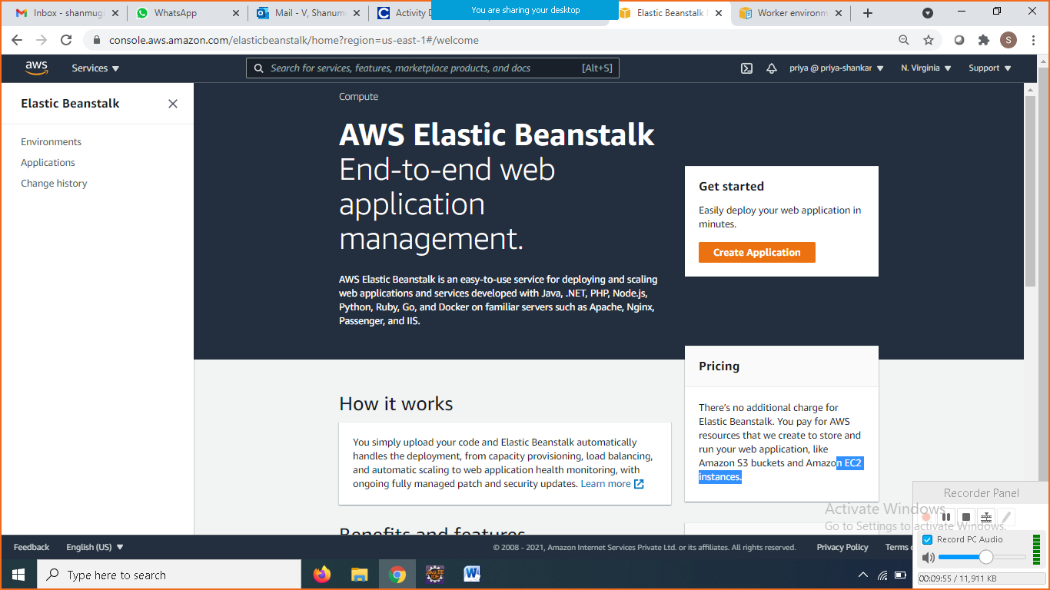

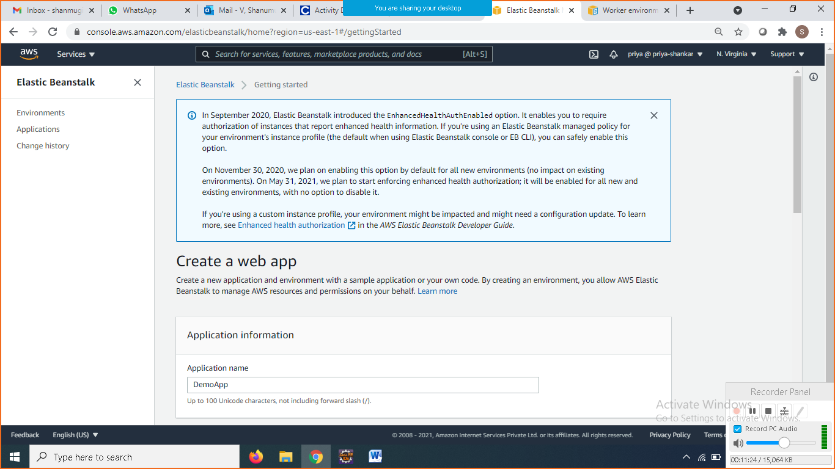

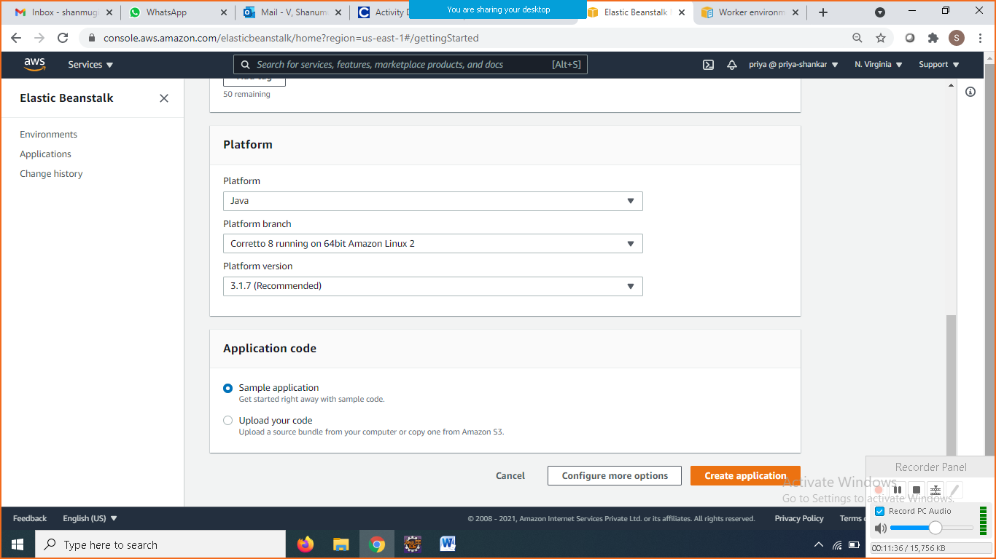

It takes few mins

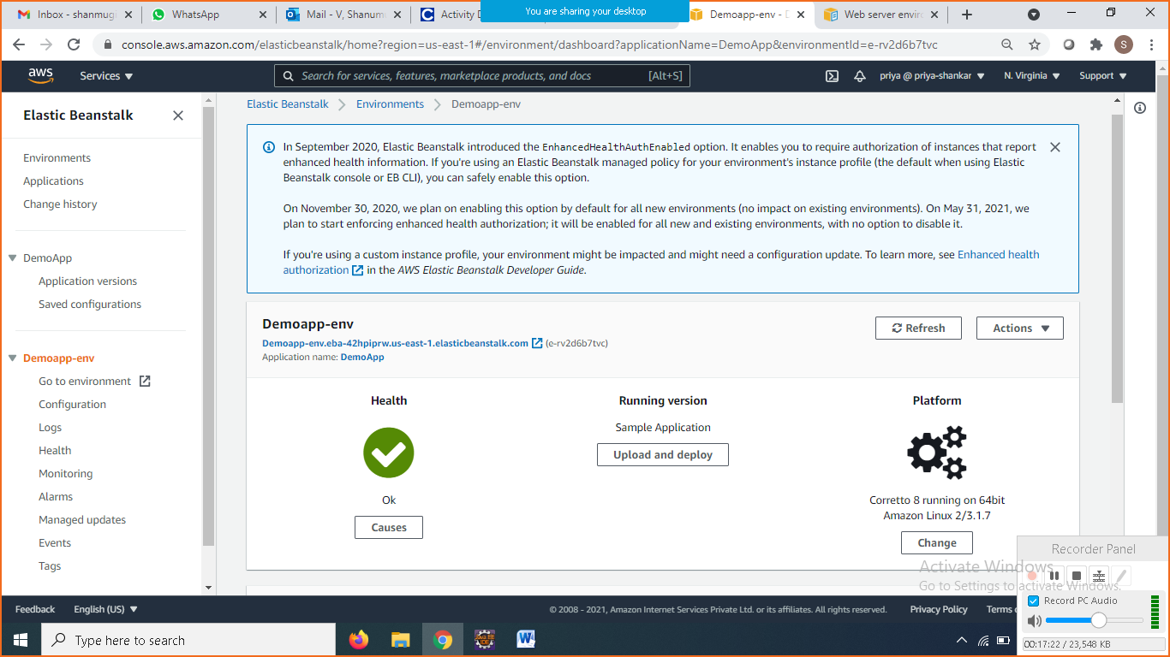

Click on the Demoapp-env url to access the application

Upload your spring app and test it

Click on upload and deploy button

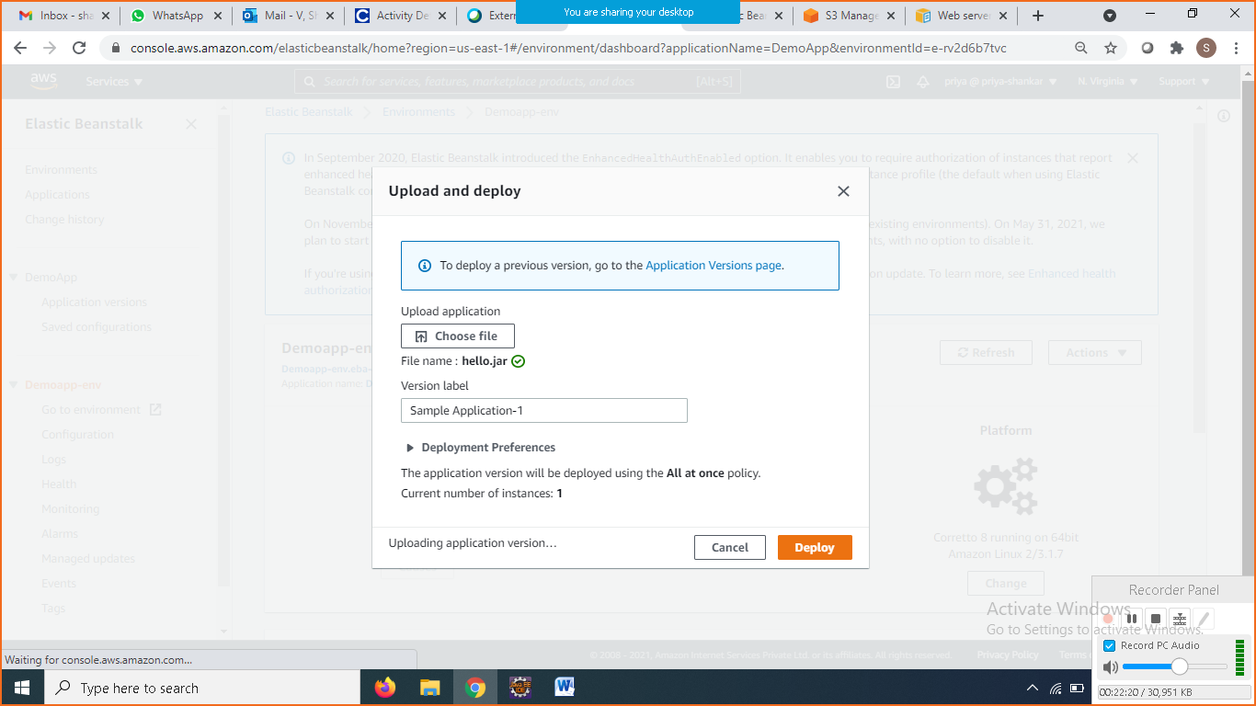

Goto Browser paste the url and check it

